**CMT112**

**WEB APPLICATION DEVELOPMENT**

----

**API FRONT-END**



C1450690

**TABLE OF CONTENTS**

INTRODUCTION 3

WIKIPEDIA and LAST FM APIs 4

GOOGLE BOOKS API 5

SONGKICK and LEAFLET APIs 6

ADDITIONAL INFORMATION 8

# INTRODUCTION

This website is dedicated to the music group Pink Floyd. The main page, when viewed on a larger device, is slightly unusual. A pig, very present in the Pink Floyd universe, appears in the middle of the page, surrounded by all of the band’s album covers. The user can navigate the pig towards each album and by doing so access information about it.

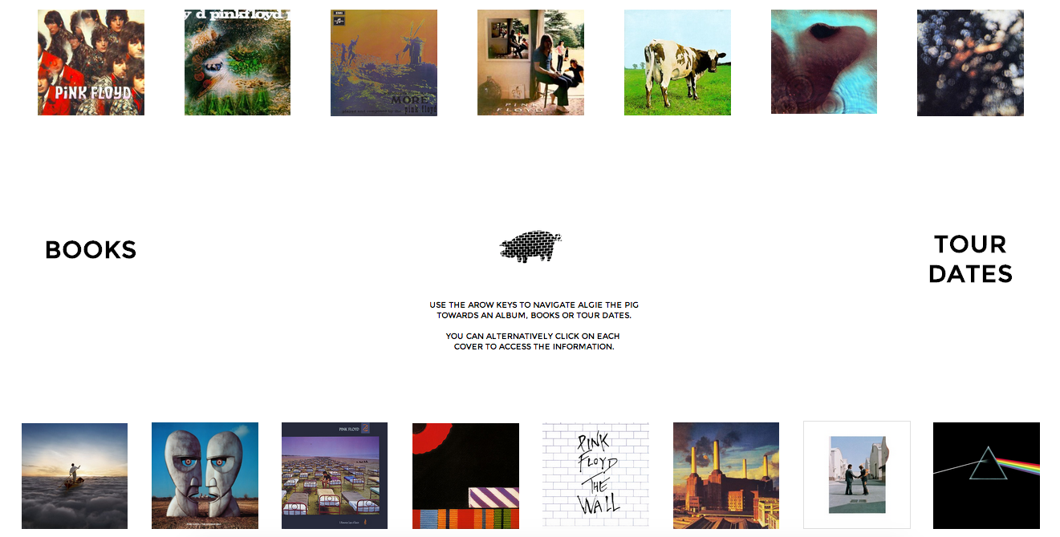

This feature has the potential to be amusing for roughly two minutes. I realised once it was completed that I had gotten caught up in writing the JavaScript without thinking of the user. I then changed the code to allow the user to just click on the section he wants to visit as well, which makes much more sense. I still left the pig in as I still think it is fun, and I had fun building it.

The website is available at:

<https://project.cs.cf.ac.uk/MezeretN/>

# WIKIPEDIA and LAST FM APIs

The calling of these two APIs was originally going to be all the website did. I wanted to create an online back catalogue for Pink Floyd by aggregating information and track listings for each album in one convenient place.

I used the Wikipedia API to retrieve the first paragraph of the album’s Wikipedia page, as well as a link to the full page. I separately called the LastFM API to get a track listing. All of this is set up side by side on a background of the album cover.

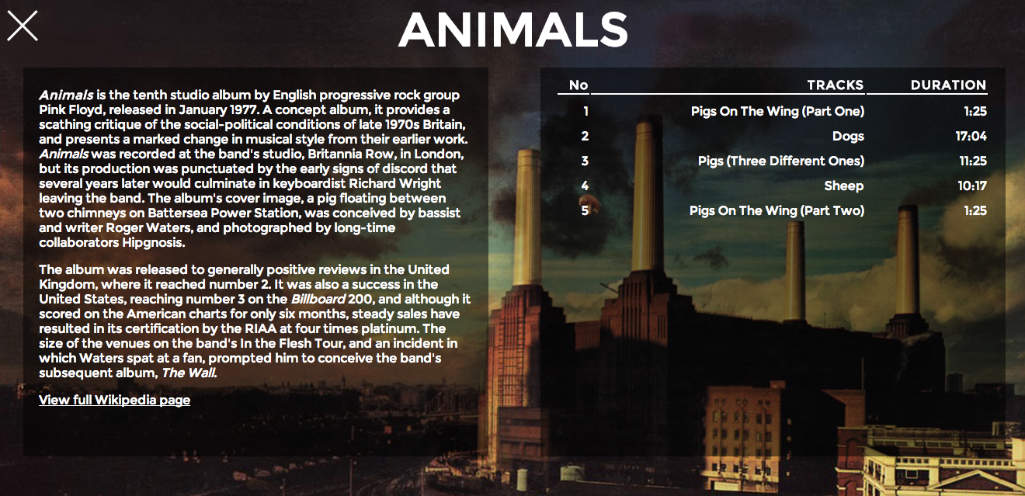

However, the only control this gives the user is picking which album page to view. Contained in the page, hidden from view, are a page ID and a LastFM name, which are used to call the APIs. While this function works well, I realised it was not working towards the essence of this assignment. I hence adjusted my vision for this site and decided to add in different functionalities that would fit the requirements better. Once again, I still left the album pages in because I think they look good, and having them is useful for a site claiming to be a Pink Floyd back catalogue.

# GOOGLE BOOKS API

My first idea to complement the albums was to use the Google Books API. Indeed, if a user were interested in all of these albums and track listings, he or she is likely to enjoy reading more about the band’s history or members.

When the user clicks on (or brings the pig over) the Books section, the Google Books API is automatically called with the query “Pink Floyd”.

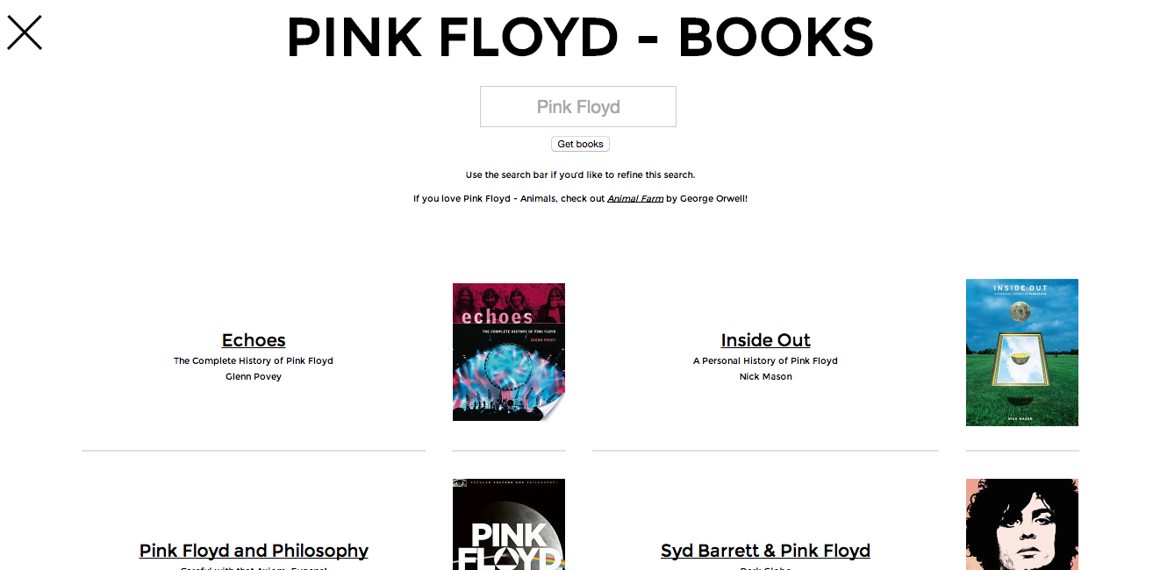

However, the user can edit this automatic search and use the search field to look for any book or author they like. They will be provided with a thumbnail of the book cover, as well as a link towards the Google Book page of each book, allowing them to buy it online, and read user reviews.

Once again however, even though this API request does take in user input, it does not truly create a functionality, a user could just as well visit the Google Books website. I personally think it is a nice addition to the site, but I thought I should add something more.

# SONGKICK and LEAFLET APIs

Once you have talked about albums and books about an artist, there is not much more to progress towards than tour dates. This is an idea I had discarded in the past, as Pink Floyd’s release of *The Endless River* has marked the end of their career as a group. However, Pink Floyd tribute bands are very common, and some even quite successful.

It stands to reason that a user looking up information about the band, reading books about it, would like to go see a nice tribute act performing. This is why I compiled a list of the most popular Pink Floyd cover bands, which the user can browse, and select an act for which he’d like to see tour dates. I also have included two band members, Roger Waters and David Gilmour, as they are still active as solo artists.

For each artist from the list the user selects, the Songkick API is called, and all upcoming concerts are displayed in a table. Once this has happened, the coordinates of each venue are fed into the Leaflet API and markers appear for each one. This helps the user better visualise the tour progress. To further benefit the user, I have used the haversine formula to calculate the distance between the user’s location (obtained with the HTML5 geolocator) and the venue location. If this distance is less than 100 kilometres (my estimate of a reasonable distance to travel to see a concert), the concerts will show up at the top of the list.

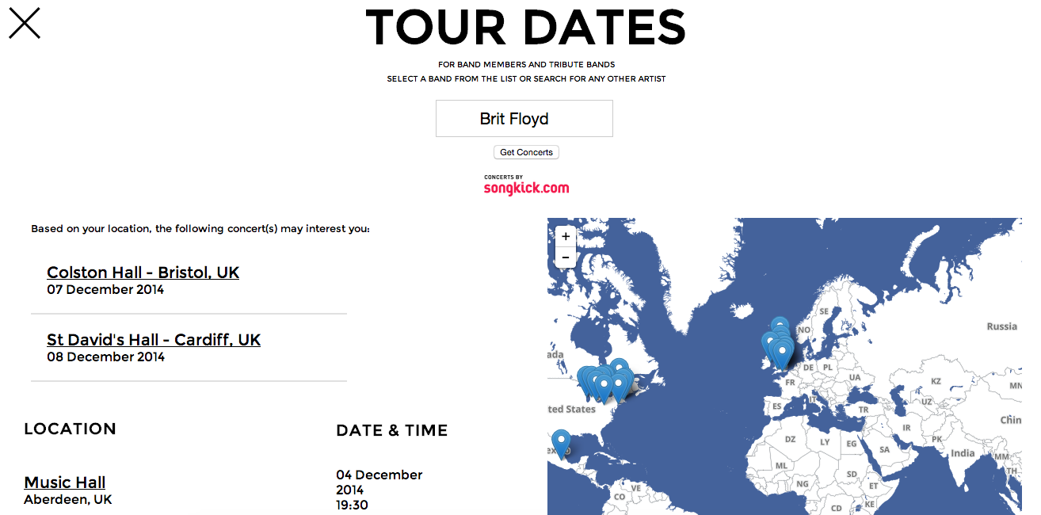

Although this functionality is not ground breaking in any way, I thought it was a quite nice combination of APIs and could be useful to Pink Floyd fans in search of a gig to attend, even if it is by a tribute band. I was also quite happy with combining all of this with another API, the Google Geocoding API. I found out on some forums, although it has not happened to me yet, that the response for some venues does not contain the geographical coordinates, making it difficult to place them on the map. Should this problem arise, the Google Gecoding API turns an address into coordinates, which are in turn fed into Leaflet.

What if the user knows of another tribute band not featured in the list? I found it very difficult to obtain tour dates straight from an user input, due to potential spelling mistakes, not getting the artist name exactly right, etc… It was to circumvent this problem that I established the list in the first place.

However, the user can still type in any artist name, and this will call on the ‘search’ method of the Songkick API, providing a list of all artists related to the user’s query. The user can then click on any artist’s name to access their Songkick page and hence their tour dates.

# ADDITIONAL INFORMATION

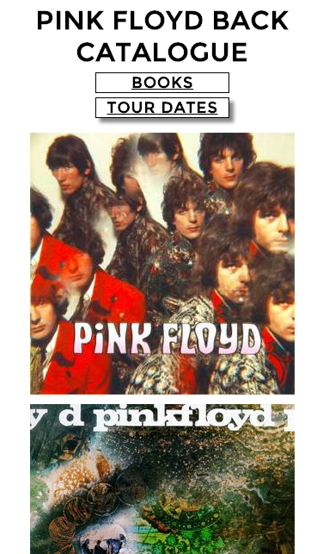

***Media Queries***

The home page was difficult to reproduce on a mobile device (for one thing the pig would become immovable), so I decided to change the design completely and have the album covers one after the other, and the user can just scroll to the one he likes.

The books and tour dates mobile pages are very similar to their desktop counterparts, just with a narrower table for the books (the thumbnails do not appear), and the concert locations appearing below the map instead of by its side for the tour dates.

The album mobile pages are quite different as the backgrounds often only come out well on horizontal windows. The backgrounds are hence omitted completely and the pages just consist of black text on a white background.

I chose the breaking point to be quite high, mostly to ensure that any mobile device would be redirected towards the mobile version. This has been done to avoid confusion on the user’s part when confronted with the main page, asking them to press arrows to move the pig.

As with the previous coursework I probably should have designed this website to fit mobile devices first, but I find it much more convenient to recreate my ideas on a larger screen.

***Other Notes***

Instead of having a ‘Back’ button and being opened in the same frame, each window opens in a new tab and can be closed by clicking the cross in the top left corner. My reasoning behind this was that the home page has many pictures and is quite heavy, and the close button system allows the user not to have to load it each time he/she has finished reading an album, for example. The only drawback is that it makes it a bit more difficult to navigate when browsing on mobile devices.

I had to download the leaflet.js file and integrate the leaflet.css to my own CSS file, as the hosted versions were not accessible using https. The leaflet CSS had 10 errors in it when I tried to validated, most of them because of inexistent properties. I have removed the lines and the map still works fine, so I have assumed these properties were not essential to what I was using the map for. I can only hope this does not cause problems in the future.

I was having trouble authorising the use of my location when running my site locally. It did however work once the whole site was uploaded to the projects site.

The font used is from Google Fonts, from a family called ‘Montserrat’.

All of the HTML used on this site has been validated as HTML 5 by the W3C Markup Validation Service (<http://validator.w3.org/>).

All of the CSS used on this site has been validated as CSS Level 3 by the W3C CSS Validation Service (<http://jigsaw.w3.org/css-validator/>).